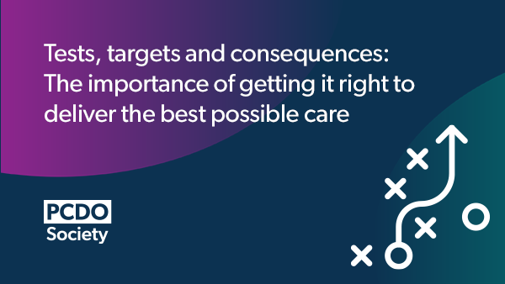

CERTIFICATE OF ATTENDANCE

This certificate confirms that

attended the

AZ webinar – Tests, targets and consequences. The importance of getting it right to deliver the best care

3 December 2025

Deborah Leatherdale
Senior Project Manager
OmniaMed Communications


Approved for 1 hour

